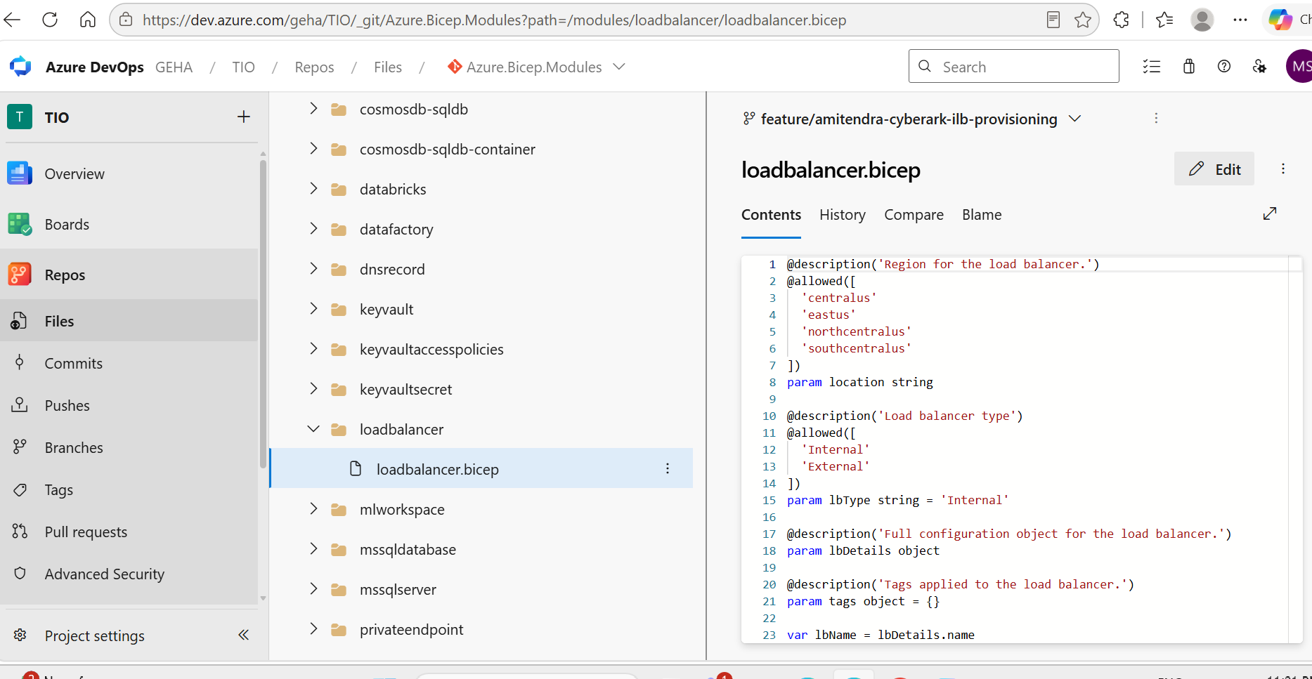
This is my loadbalncer.bicep file
@description('Region for the load balancer.')
@allowed([
'centralus'
'eastus'
'northcentralus'
'southcentralus'
])
param location string

@description('Load balancer type')
@allowed([
'Internal'
'External'
])
param lbType string = 'Internal'

@description('Full configuration object for the load balancer.')
param lbDetails object

@description('Tags applied to the load balancer.')
param tags object = {}

var lbName = lbDetails.name
var feName = 'fe-${lbName}'
var poolName = 'bep-${lbName}'

// Accept either the v1.1.0 probes array or the v1.0.0 singular probe.
var probeList = lbDetails.?probes ?? [lbDetails.probe]

resource publicIp 'Microsoft.Network/publicIPAddresses@2024-05-01' = if (lbType == 'External') {
name: '${lbName}-pip'
location: location
tags: tags
sku: {
name: 'Standard'
tier: 'Regional'
}
zones: [
'1'
'2'
'3'
]
properties: {
publicIPAllocationMethod: 'Static'
}
}

resource loadBalancer 'Microsoft.Network/loadBalancers@2024-05-01' = {
name: lbName
location: location
tags: tags
sku: {
name: 'Standard'
tier: 'Regional'
}
properties: {
frontendIPConfigurations: [
{
name: feName
zones: lbDetails.?frontendZones ?? [
'1'
'2'
'3'
]
properties: lbType == 'Internal'
? {
subnet: {
id: lbDetails.subnetId
}
privateIPAllocationMethod: 'Static'
privateIPAddress: lbDetails.privateIPAddress
}
: {
publicIPAddress: {
id: publicIp.id
}
}
}
]

backendAddressPools: [
{
name: poolName
}
]

probes: [
for p in probeList: {
name: p.name
properties: union(
{
protocol: p.?protocol ?? 'Tcp'
port: p.port
intervalInSeconds: p.?intervalInSeconds ?? 30
numberOfProbes: p.?probeThreshold ?? 3
probeThreshold: p.?probeThreshold ?? 3
},
contains(p, 'requestPath')
? {
requestPath: p.requestPath
}
: {}
)
}
]

loadBalancingRules: [
for rule in lbDetails.rules: {
name: rule.name
properties: {
frontendIPConfiguration: {
id: resourceId(
'Microsoft.Network/loadBalancers/frontendIPConfigurations',
lbName,
feName
)
}

backendAddressPool: {
id: resourceId(
'Microsoft.Network/loadBalancers/backendAddressPools',
lbName,
poolName
)
}

probe: {
id: resourceId(
'Microsoft.Network/loadBalancers/probes',
lbName,
rule.?probeName ?? probeList[0].name
)
}

protocol: rule.?protocol ?? 'Tcp'
frontendPort: rule.port
backendPort: rule.?backendPort ?? rule.port
loadDistribution: lbDetails.?loadDistribution ?? 'Default'
idleTimeoutInMinutes: lbDetails.?idleTimeoutInMinutes ?? 20
enableTcpReset: lbDetails.?enableTcpReset ?? true
enableFloatingIP: false
disableOutboundSnat: true
}
}
]
}
}

output loadBalancerName string = loadBalancer.name
output loadBalancerId string = loadBalancer.id
output backendAddressPoolId string = resourceId('Microsoft.Network/loadBalancers/backendAddressPools',lbName,poolName)
output frontendIp string = lbType == 'Internal'? lbDetails.privateIPAddress: publicIp.properties.ipAddress
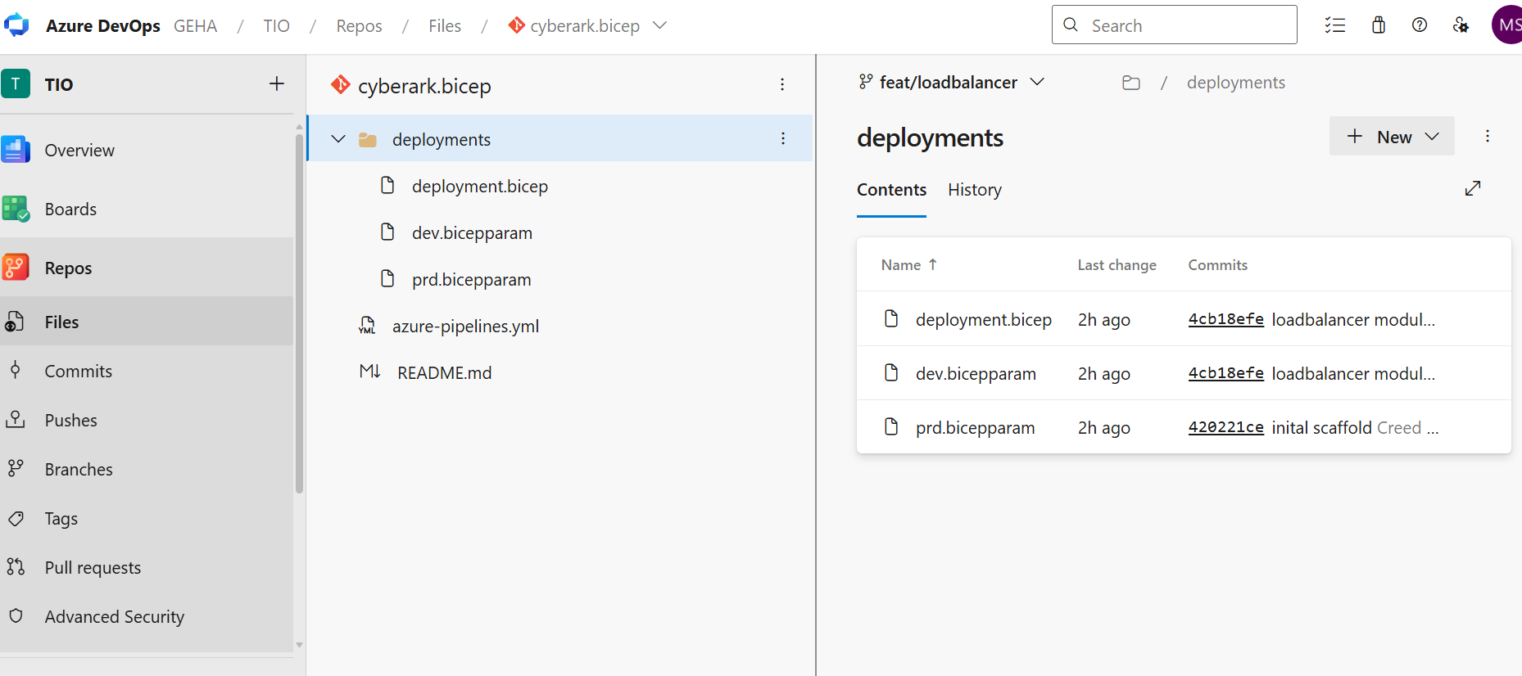
deployment.bicep
param deploymentTimeStamp string = utcNow('yyyyMMddHHmmss')

param env string
param lbDetails object

module loadbalancer 'br:gehabicep.azurecr.io/bicep/modules/loadbalancer:v1.0.0' = {
name: 'lb-${deploymentTimeStamp}'
params: {
location: location
lbType: 'Internal'
tags: {
Environment: env
Application: 'CyberArk'
}
lbDetails: {
name: name
subnetId: subnetId
privateIPAddress: '10.9.18.50'
}
}
}

dev.bicepparam
using 'deployment.bicep'
param env = 'dev'
param location string = 'centralus'
param lbType string = 'Internal'
param lbDetails object
param name string = 'cyberark-loadbalancer-dev'
param tags object = {}
param subnetId string = '/subscriptions/e657afbe-61e4-4a5f-b6cb-cfbba50fd3a6/resourceGroups/rg-alz-centralus-vnet-cip-cus-dev-01/providers/Microsoft.Network/virtualNetworks/vnet-cip-cus-dev-01/subnets/snet-cip-dev-01'
param lbDetails = {
subnetId: subnetId
name: name
privateIPAddress: '10.9.18.50'
}
This is error
2026-09-30T17:01:09.9786026Z WARNING: /home/vsts/work/1/s/self/deployments/deployment.bicep(4,7) : Warning no-unused-params: Parameter "lbDetails" is declared but never used. [https://aka.ms/bicep/linter-diagnostics#no-unused-params]
2026-09-30T17:01:10.2104393Z ERROR: /home/vsts/work/1/s/self/deployments/deployment.bicep(9,15) : Error BCP057: The name "location" does not exist in the current context. [https://aka.ms/bicep/core-diagnostics#BCP057]
2026-09-30T17:01:10.2133790Z /home/vsts/work/1/s/self/deployments/deployment.bicep(16,13) : Error BCP057: The name "name" does not exist in the current context. [https://aka.ms/bicep/core-diagnostics#BCP057]
2026-09-30T17:01:10.2153831Z /home/vsts/work/1/s/self/deployments/deployment.bicep(17,17) : Error BCP057: The name "subnetId" does not exist in the current context. [https://aka.ms/bicep/core-diagnostics#BCP057]
2026-09-30T17:01:10.4243549Z
2026-09-30T17:01:10.4290031Z ##[error]Script failed with exit code: 1
2026-09-30T17:01:10.4305060Z [command]/usr/bin/az account clear
2026-09-30T17:01:11.2753561Z ##[section]Finishing: Bicep Compile deployments/deployment.bicep

